**Program 1**

**Problem Statement** - Create an html page named as “: Basic_Html_Tags.html” Add the following tags detail. 1. Set the title of the page as “Basic Html Tags”.

**Code –**

<!DOCTYPE html>

<html lang="en">

<head>

<meta charset="UTF-8">

<meta http-equiv="X-UA-Compatible" content="IE=edge">

<meta name="viewport" content="width=device-width, initial-scale=1.0">

<title>Document</title>

</head>

<body>

<h2 align="center">Basic HTML Tags</h2>

<h1 align="center" style="color: red;">Heading Tags=>font size- 18pt, color-Red</h1>

<h1 align="center">Heading H1 - 24 pt</h1>

<h3><b>Heding H3- 12 pt bold</b></h3>

<h4>Heading H4- 12 pt</h4>

<h5>Heading H5- 10 pt</h5>

<h6>Headinf H6- 7 pt</h6>

<p style="font-size: 36pt;">Font size- 30 pt</p>

<p style="font-size: 24pt;">Font size- 24 pt</p>

<p style="font-size: 18pt;">Font size- 18 pt</p>

<p style="font-size: 12pt;"><b>Font size- 12 pt</b></p>

<p style="font-size: 9pt;"><b>Font size- 9 pt</b></p>

<h2 align="center" style="color: green;">Text Elements => font size-12pt,<color-Green></color-Green></h2>

<blockquote>Lorem ipsum dolor sit amet consectetur adipisicing elit. Soluta non suscipit quia sunt! Aspernatur ex suscipit provident id consequatur veritatis molestias quasi aperiam, qui officia sunt deserunt laudantium temporibus, ab voluptates sit delectus deleniti maiores saepe est placeat earum, possimus natusblockquote>

</body>

</html>

**OUTPUT**

**Program 2**

**Problem Statement** - To create a simple html file to demonstrate the use of list tags (ordered list).

**Code –**

<!DOCTYPE html>

<html lang="en">

<head>

<meta charset="UTF-8">

<meta http-equiv="X-UA-Compatible" content="IE=edge">

<meta name="viewport" content="width=device-width, initial-scale=1.0">

<title>Listing Tags</title>

</head>

<body>

<center><FONT COLOR="#0000FF"> Listing Tags</FONT></center>

<h4>Numbered list:</h4>

<ol><li>java</li>

<li>perl</li>

<li>c++</li>

</ol>

<h4>Letters list:</h4>

<ol type="A">

<li>smtp</li> <li>http</li> <li>ftp</li>

</ol>

<h4>Lowercase letters list:</h4>

<ol type="a" start="2">

<li>php</li> <li>javascript</li> <li>ajax</li>

</ol>

<h4>Roman numbers list:</h4>

<ol type="I">

<li>DTE</li>

<li>JCTE</li>

<li>SITTTR</li>

</ol>

<h4>Lowercase Roman numbers list:</h4>

<ol type="i" start="4" >

<li>Computer Engg.</li>

<li>Mechanical Engg.</li>

<li>Electronics Engg.</li>

</ol>

</body>

</html>

**OUTPUT**

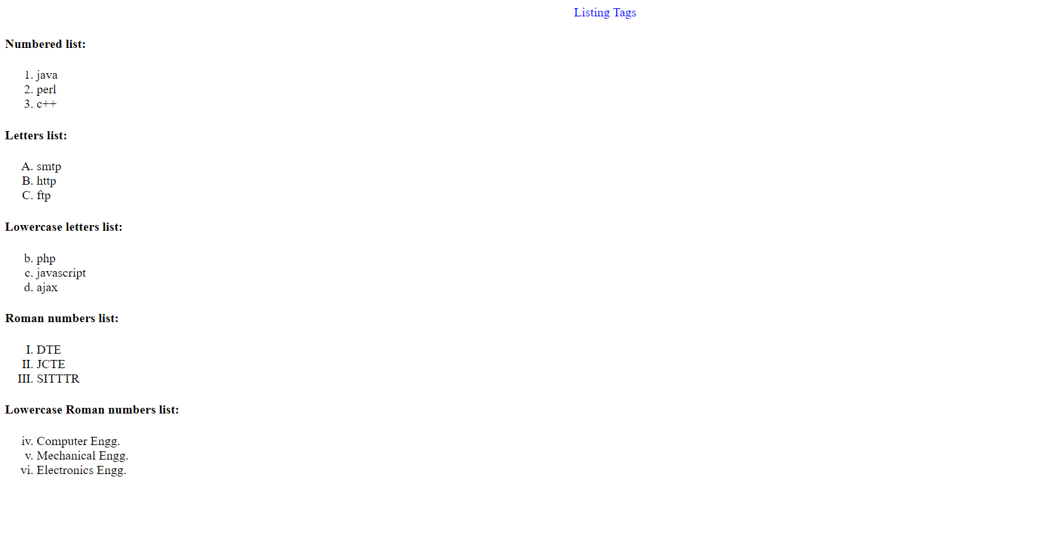

**Program 3**

**Problem statement** - To create a simple html file to demonstrate the use of list tags (unordered list and unordered ).

**Code** –

<!DOCTYPE html>

<html lang="en">

<head>

<meta charset="UTF-8">

<meta http-equiv="X-UA-Compatible" content="IE=edge">

<meta name="viewport" content="width=device-width, initial-scale=1.0">

<title>Document</title>

</head>

<body>

<h4>Here is a nested ordered List:</h4>

<ol type="I"><li>Module 1</li>

<li>Module 2</li>

<ol type="i">

<li>Module 2.1</li>

<li>Module 2.2</li>

</ol>

<li>Module 3</li>

</ol>

<h4>Disc Bulltes list :</h4>

<ul>

<li>Keyborad</li>

<li>Mouse</li>

<li>Monitor</li>

</ul>

<h4>Circle bulltes list</h4>

<ul type="circle">

<li>CRT</li>

<li>LCD</li>

<li>LED</li>

</ul>

<h4>Square Bulltes list: </h4>

<ul type="square">

<li>Windows</li>

<li>Linux</li>

<li>Android</li>

</ul>

<h4>A Defination List : </h4>

<dl>

<dl>Coffee</dl>

<dd>Black Coffess OR Milk Coffee</dd>

<dl>Milk</dl>

<dd> Hot Coffee milk OR Cold Chocolate Milk</dd>

</dl>

</body>

</html>

**OUTPUT**

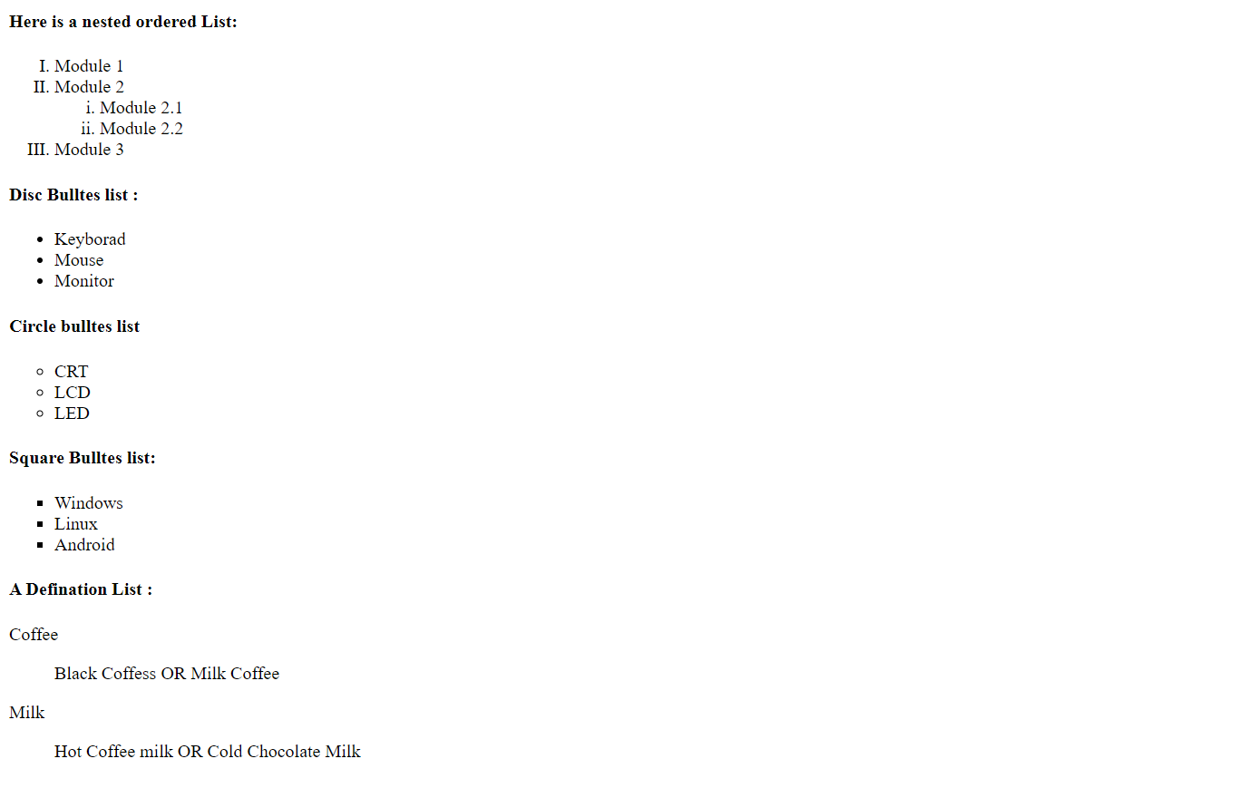

**Program 4**

**Problem Statement** - To create a simple html file to demonstrate the use of different list tags.

**Code –**

<!DOCTYPE html>

<html lang="en">

<head>

<meta charset="UTF-8">

<meta http-equiv="X-UA-Compatible" content="IE=edge">

<meta name="viewport" content="width=device-width, initial-scale=1.0">

<title>Document</title>

</head>

<body>

<br><br>

<Center><FONT >Government Polytechnic College </Center>

<Center>DEPARTMENT OF COMPUTER ENGINEERING </Center>

<Center>EFFECTIVE FROM:01-07-2016</Center>

<br><br><br><br><br>

<table border="3" cellspacing="2" width="400" align="center" >

<span style="margin-left: 34em;">SEMESTER 5 CT</span>

<span style="margin-left: 15rem;">R.No:306</span>

<tr>

<th style="background-color: #ffe100;">Period</th>

<th rowspan="2" style="background-color: rgb(250, 190, 210);">1 <br><br> 09:00-09:55</th>

<th rowspan="2" style="background-color: rgb(250, 190, 210);">2 <br><br>09:55-10:50</th>

<th rowspan="2" style="background-color: rgb(250, 190, 210);">3 <br><br>11:00-11:55</th>

<th rowspan="2" style="background-color: rgb(250, 190, 210);">4 <br><br>11:55-01:00</th>

<th rowspan="2" style="background-color: rgb(250, 190, 210);">5 <br><br>02:00-02:50</th>

<th rowspan="2" style="background-color: rgb(250, 190, 210);">6 <br><br>02:55-03:45</th>

<th rowspan="2" style="background-color: rgb(250, 190, 210);">7 <br><br>03:45-04:30</th>

</tr>

<tr>

<th style="background-color: rgb(209, 8, 8);">Days</th>

</tr>

<tr>

<th style="background-color: silver;">Monday</th>

<td>IT0302</td>

<td>IT0306</td>

<td>IT0304</td>

<td>IT0306</td>

<td>IT0302</td>

<td colspan="2" align="center">IT0324</td>

</tr>

<tr>

<th style="background-color: silver;">Tuesday</th>

<td colspan="4" align="center" style="background-color: rgb(93, 197, 249);">IT0302/IT032</td>

<td style="background-color: rgb(179, 179, 14);">IT0310</td>

<td>IT0304</td>

<td>IT0308</td>

</tr>

<tr>

<th style="background-color: silver;">Wednesday</th>

<td colspan="2" style="background-color: yellow;" align="center">ELECTIVE-1</td>

<td>IT0306</td>

<td>IT0310</td>

<td>IT0304</td>

<td>IT0308</td>

<td>COUN</td>

</tr>

<tr>

<th style="background-color: silver;">Thursday</th>

<td>IT0302</td>

<td>IT0304</td>

<td colspan="2" align="Center">PD0302</td>

<td colspan="3" align="center" style="background-color: green;">IT0320/IT0322</td>

</tr>

<tr>

<th style="background-color: silver;">Friday</th>

<td>IT0308</td>

<td>IT0306</td>

<td>IT0308</td>

<td>IT0302</td>

<td colspan="2" align="center" style="background-color: red;">ELECTIVE-1</td>

<td></td>

</tr>

</table>

</body>

</html>

**OUTPUT**

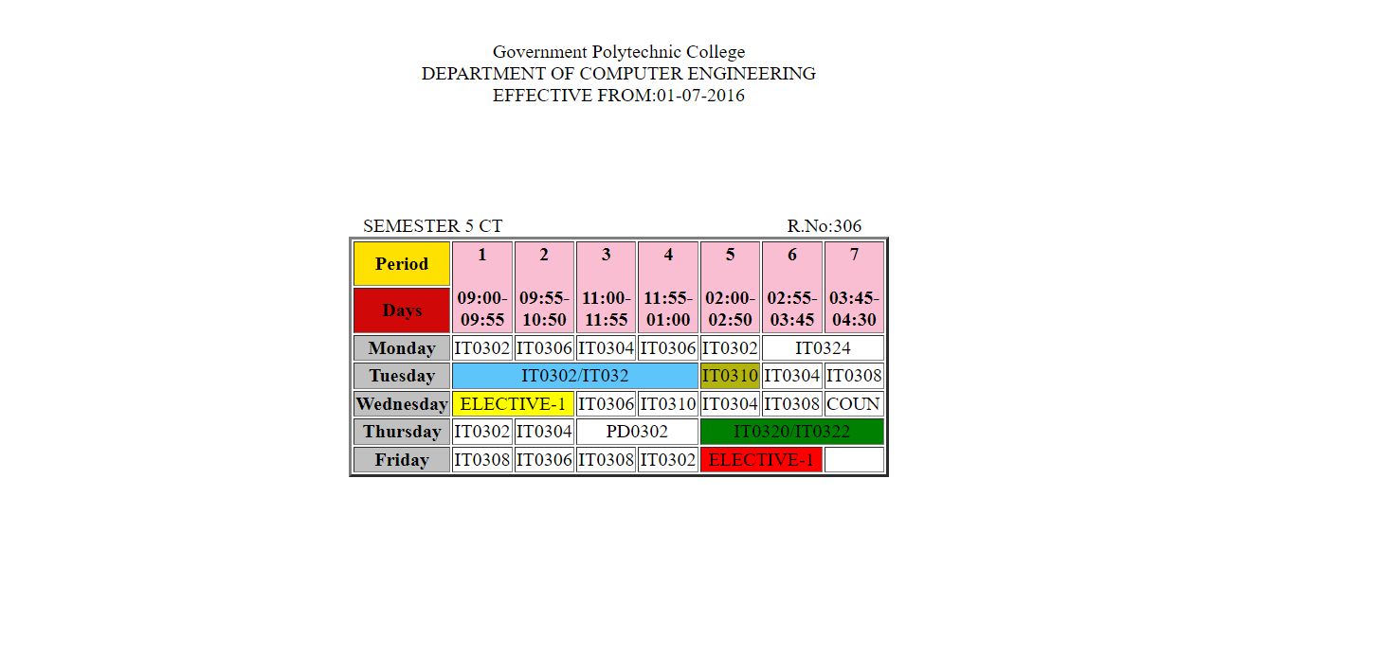

**Program 5**

**Problem Statement** – To create a simple html file to demonstrate the Forms in Html.

**Code –**

<!DOCTYPE html>

<html lang="en">

<head>

<meta charset="UTF-8">

<meta http-equiv="X-UA-Compatible" content="IE=edge">

<meta name="viewport" content="width=device-width, initial-scale=1.0">

<title>Html Form</title>

</head>

<body>

<center style="color: brown; font-size: larger; font-weight: bold;">ENTRY FORM</center>

<br><br><br><br>

<form target="_blank" method="post">

<span style="margin-left: 8em;">Enter your name: </span>

<input type="text" style="margin-left: 4em;">

<br><br><br>

<span style="margin-left: 8em;">Enter your Age:</span>

<input type="text" style="margin-left:4.5em ;">

<br><br><br>

<span style="margin-left: 8em;">Enter your Address : </span>

<input type="text" style="margin-left: 2.5em;">

<br><br><br>

<span style="margin-left: 8em;">Sex:</span>

<input type="radio" name="gender" id="male" style="margin-left: 11em;">

<label for="male">Male</label><br>

<input type="radio" name="gender" id="female" style="margin-left: 23em;">

<label for="female">Female</label>

<br><br><br>

<span style="margin-left: 8em;">Nationality: </span>

<select name="country" style="margin-left: 7em;">

<option value="India">India</option>

<option value="America">America</option>

<option vaue="Sri Lanka">Sri Lanka</option>

</select>

<br><br><br>

<span style="margin-left: 8em;">Languages Known :</span>

<input type="checkbox" name="lang" id="c" style="margin-left: 3em;">

<label for="c" >C</label>

<br>

<input type="checkbox" name="lang" id="c++" style="margin-left: 22.5em;">

<label for="c++">C++</label>

<br>

<input type="checkbox" name="lang" id="vb" style="margin-left: 22.5em;">

<label for="vb">Vb</label>

<br>

<input type="checkbox" name="lang" id="java" style="margin-left: 22.5em;">

<label for="java">Java</label>

<br>

<input type="checkbox" name="lang" id="asp" style="margin-left: 22.5em;">

<label for="asp">ASP</label>

<br>

<input type="checkbox" name="lang" id="other" style="margin-left: 22.5em;">

<label for="other">Others</label>

<br><br><br>

<span style="margin-left: 8em;">Enter your password: </span>

<input type="password" style="margin-left: 2em;">

<br><br><br>

<button style="margin-left: 22em;">Submit</button>

<button>Reset</button>

</form></body></html

**OUTPUT**

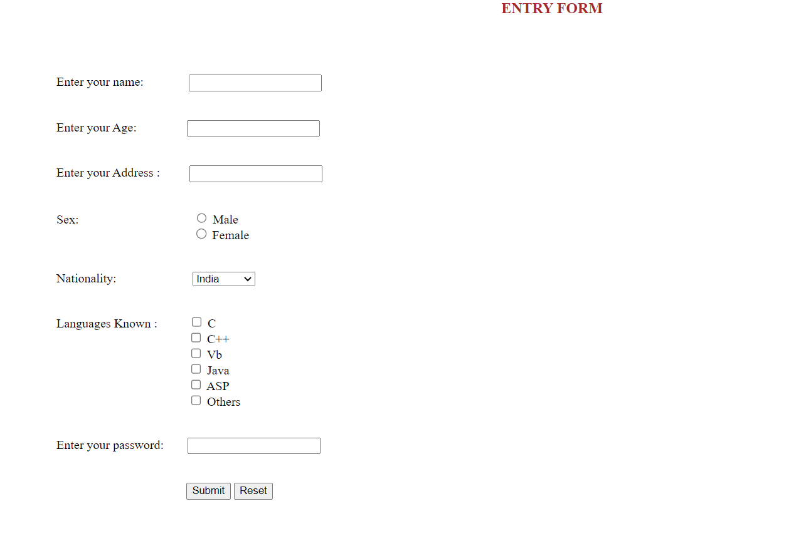

**Program 6**

**Problem Statement** - Create an html page named as “frames.html”. Divide the page into two columns of 20%, 80% size. In 20% size call the hyperlinks for “navigationframes.html”, “floatingframes.html”, “mixedframe.html”, “noframe” and make the page to be get displayed on the other column when these links are clicked.

**Code –**

**Frame set file Code**

<!DOCTYPE html>

<html lang="en">

<head>

<meta charset="UTF-8">

<meta http-equiv="X-UA-Compatible" content="IE=edge">

<meta name="viewport" content="width=device-width, initial-scale=1.0">

<frameset cols="20%,80%">

<frame name="first" src="first_frame.html" ></frame>

<frame name="second">hii</a>

</frameset>

<title>Document</title>

</head>

</html>

**OUTPUT**

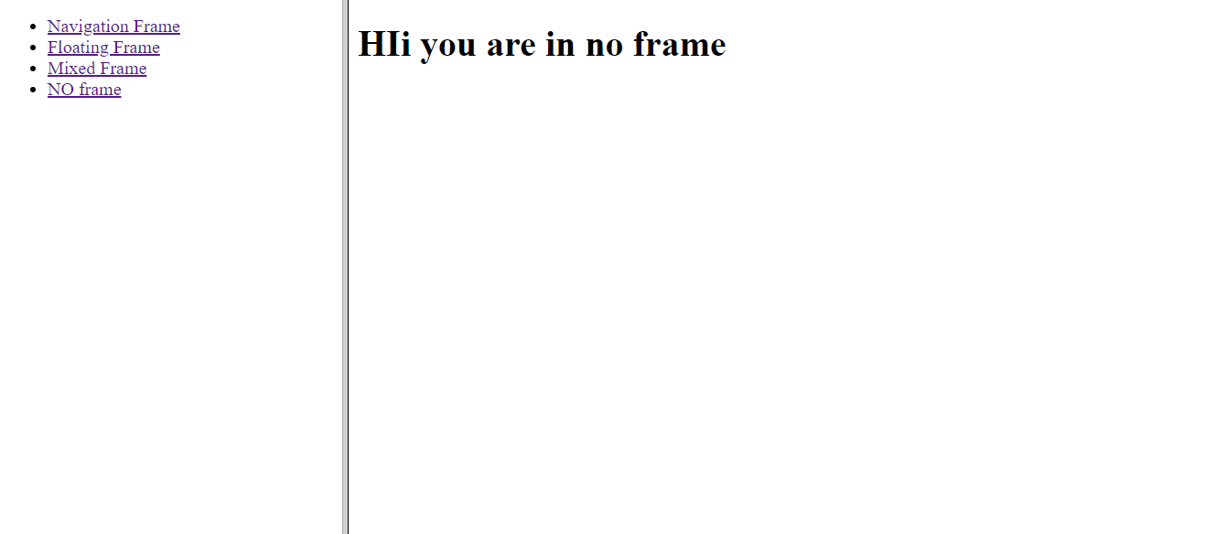

**Program 7**

**Problem Statement** - Create an html page named as “navigationframe.html”. Divide the page into two columns of 40%, 60% size. In 40% size call the hyperlink file created in above exercise , and make the page to be get displayed on the other column when the link is clicked

**Code –**

**Navigation file code**

<!DOCTYPE html>

<html lang="en">

<head>

<meta charset="UTF-8">

<meta http-equiv="X-UA-Compatible" content="IE=edge">

<meta name="viewport" content="width=device-width, initial-scale=1.0">

<title>Document</title>

<frameset cols="40%,60%">

<frame name="first" src="first_frame.html"></frame>

<frame name="second" ></frame>

</frameset>

</head>

<body>

<h1>we are in navigation plane</h1>

</body>

</html>

**OUTPUT**

**When you clicked on Navigation Frame Link**

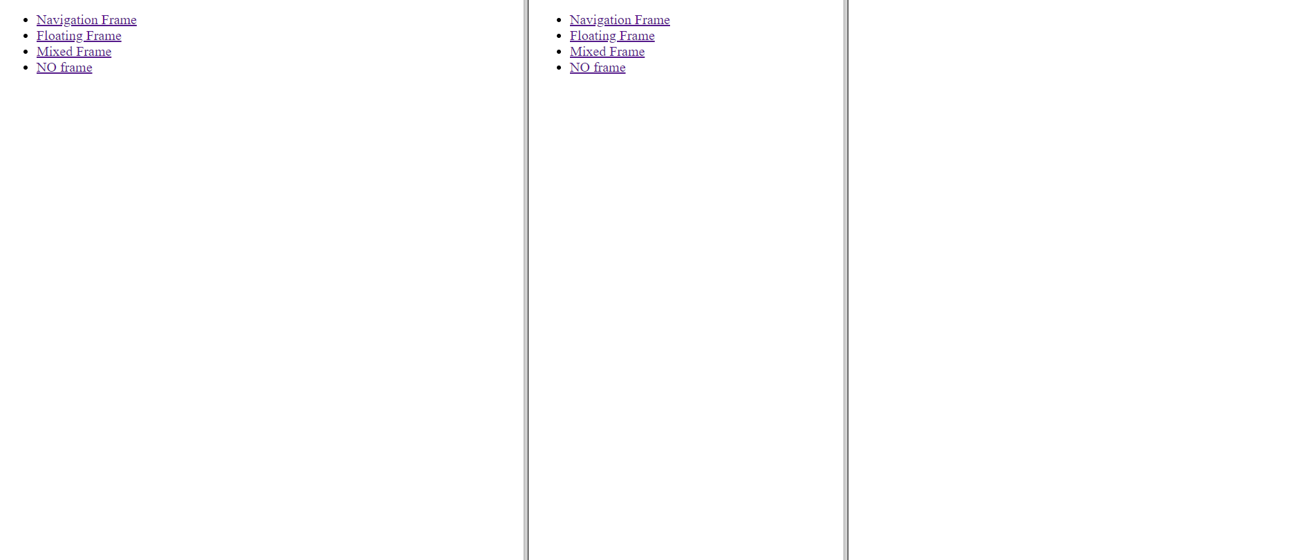

**Program 8**

**Problem Statement** - Create an html page named as “floatingframes.html”. In this file include a paragraph to explain floating frame, and in floating frame include the any html file created in the above exercise as inline.

**Code –**

<!DOCTYPE html>

<html lang="en">

<head>

<meta charset="UTF-8">

<meta http-equiv="X-UA-Compatible" content="IE=edge">

<meta name="viewport" content="width=device-width, initial-scale=1.0">

<title>Document</title>

</head>

<body>

<h1>We are in floating frame</h1>

<a href="navigationframes.html">This is the page i have included that was made in previous exercise</a>

</body>

</html>

**OUTPUT**



**After clicking this hyperlink**

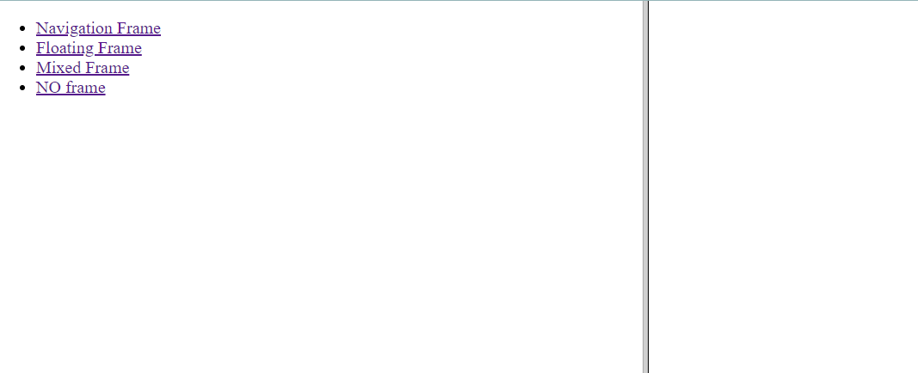

**Program 9**

**Problem Statement** - Create an html page named as “mixedframe.html” . Divide the page into two columns of 25% & 75% size. In 25% display an image and divide the 75% into two rows. (50% & 50%). In the first 50% display the video file created in previous exercise and other 50% the time table created in previous exercise.

**Code –**

**Mixed avigation file code**

<!DOCTYPE html>

<html lang="en">

<head>

<meta charset="UTF-8">

<meta http-equiv="X-UA-Compatible" content="IE=edge">

<meta name="viewport" content="width=device-width, initial-scale=1.0">

<title>Document</title>

<frameset cols="25%,75%">

<frame name="first" src="display_img.html"></frame>

<frame name="second" src="divide.html"></frame>

</frameset>

</head>

<body>

<h2>Hii you are in mixed frame</h2>

</body>

</html>

**Divide.html file code**

<!DOCTYPE html>

<html lang="en">

<head>

<meta charset="UTF-8">

<meta http-equiv="X-UA-Compatible" content="IE=edge">

<meta name="viewport" content="width=device-width, initial-scale=1.0">

<title>Document</title>

<frameset rows="50%,50%">

<frame src="ques_6_c.html"></frame>

<frame src="time_table_csit.html"></frame>

</frameset>

</head>

<body>

</body>

</html>

**Display_img file code**

<!DOCTYPE html>

<html lang="en">

<head>

<meta charset="UTF-8">

<meta http-equiv="X-UA-Compatible" content="IE=edge">

<meta name="viewport" content="width=device-width, initial-scale=1.0">

<title>Document</title>

</head>

<body>

<img src="1.png">

</body>

</html>

**OUTPUT**

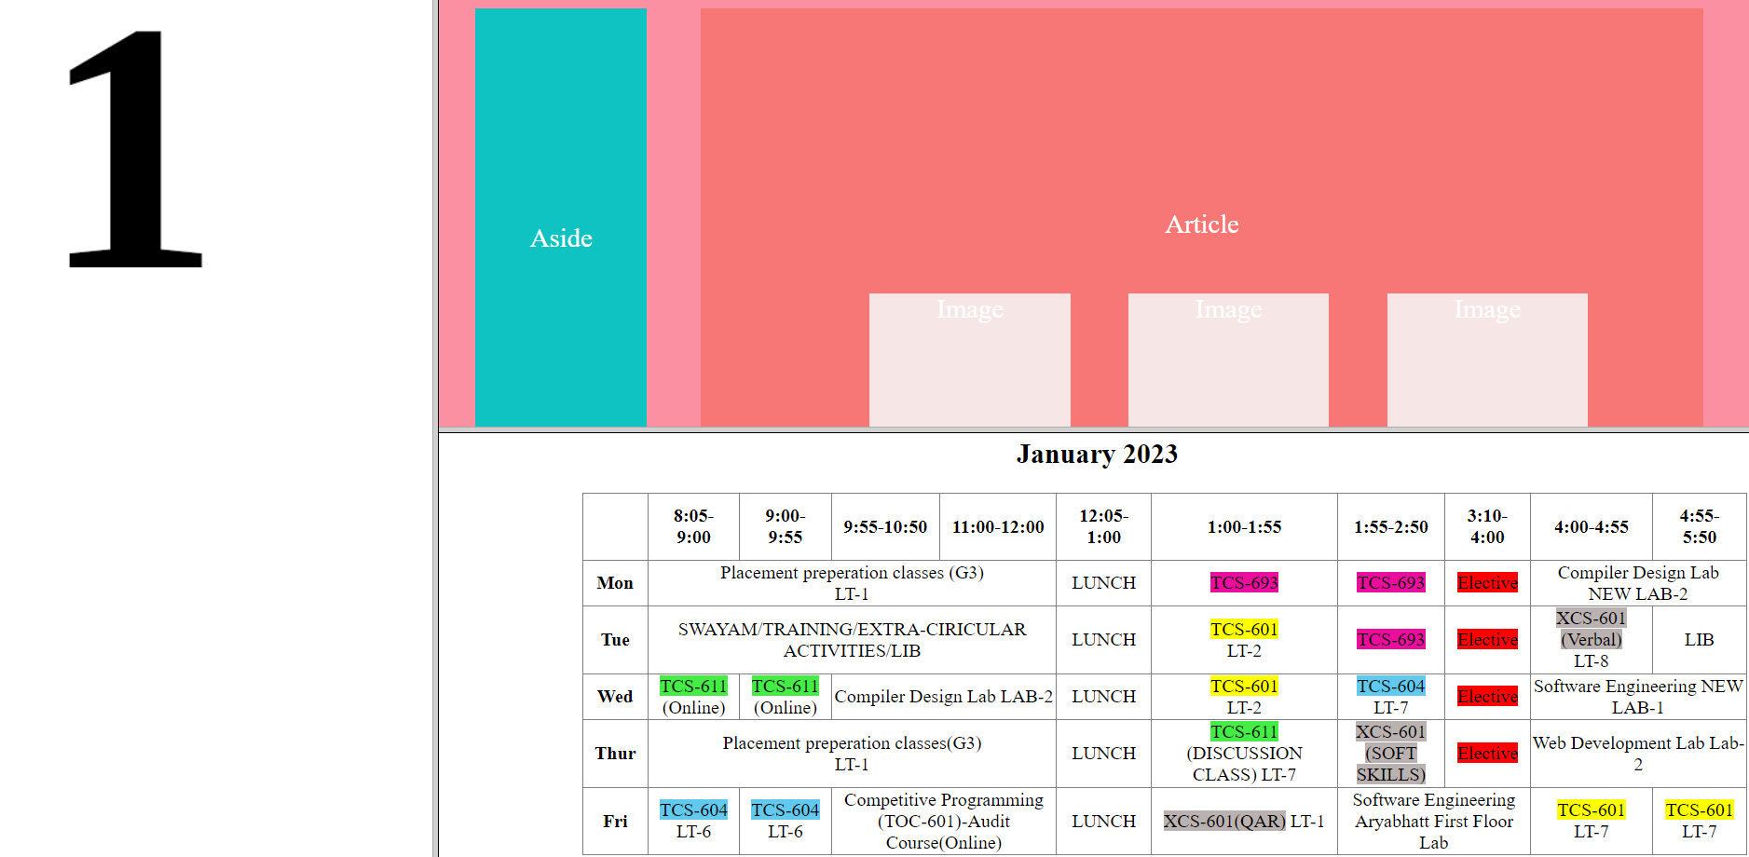

**Problem 9**

**Problem Statement** - To display an image on the website and construct a map for all circle buttons, develop the "dialler.html" HTML page. When you click on a circle, a message with a button number, such as "you push button 1," will appear.

**Code –**

<!DOCTYPE html>

<html lang="en">

<head>

<meta charset="UTF-8">

<meta http-equiv="X-UA-Compatible" content="IE=edge">

<meta name="viewport" content="width=device-width, initial-scale=1.0">

<title>Dialer</title>

</head>

<body>

<map name="circle-map">

<area shape="circle" coords="150,100,50" href="#" onclick="alert('You pushed button 1')" alt="Button 1">

<area shape="circle" coords="260,100,50" href="#" onclick="alert('You pushed button 2')" alt="Button 2">

<area shape="circle" coords="380,100,50" href="#" onclick="alert('You pushed button 3')" alt="Button 3">

<area shape="circle" coords="150,220,50" href="#" onclick="alert('You pushed button 4')" alt="Button 4">

<area shape="circle" coords="260,220,50" href="#" onclick="alert('You pushed button 5')" alt="Button 5">

<area shape="circle" coords="380,220,50" href="#" onclick="alert('You pushed button 6')" alt="Button 6">

<area shape="circle" coords="150,330,50" href="#" onclick="alert('You pushed button 7')" alt="Button 7">

<area shape="circle" coords="260,330,50" href="#" onclick="alert('You pushed button 8')" alt="Button 8">

<area shape="circle" coords="380,330,50" href="#" onclick="alert('You pushed button 9')" alt="Button 9">

<area shape="circle" coords="150,440,50" href="#" onclick="alert('You pushed button *')" alt="Button *">

<area shape="circle" coords="260,440,50" href="#" onclick="alert('You pushed button 0')" alt="Button 0">

<area shape="circle" coords="380,440,50" href="#" onclick="alert('You pushed button #')" alt="Button #">

</map>

<img src="calc.jpeg" alt="Image" usemap="#circle-map">

</body>

</html>

**OUTPUT**

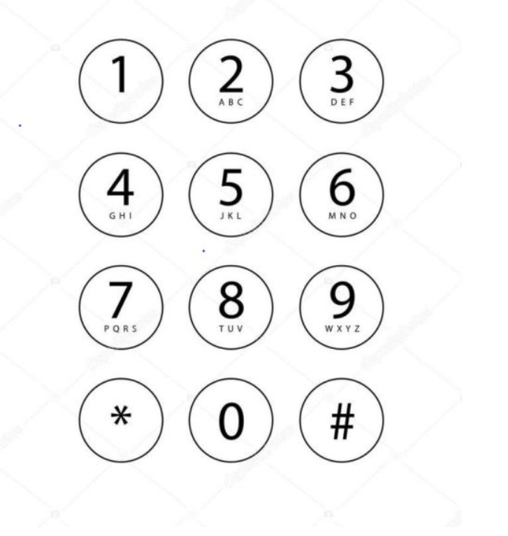

**After clicking one of the button**

**Program 10**

**Problem Statement** - To create an html file by applying the different styles using inline, external & internal style sheets.

**Code –**

<!DOCTYPE html>

<html lang="en">

<head>

<meta charset="UTF-8">

<meta http-equiv="X-UA-Compatible" content="IE=edge">

<meta name="viewport" content="width=device-width, initial-scale=1.0">

<title>Document</title>

<style>

h1

{

background-color: yellow;

text-align:center;

color: green;

border:10px solid red;

}

div span

{

color: red;

margin-left: 100px;

}

h2

{

color: purple;

background-color: pink;

border-style: dashed;

}

h3

{

color:red;

}

ol

{

background-color: greenyellow;

color:red;

border-style:dashed ;

border-color: purple;

text-transform:initial;

}

ol span

{

font-size: 30px;

font-weight: solid;

}

</style>

</head>

<body>

<h1>This Is My Stylish Website</h1>

<div>

<span>Home</span>

<span>Backgrounds</span>

<span>Lists</span>

<span>Id vs Class</span>

</div>

<h2>This website is abount me!</h2>

<h3>My Top Three Favourite Things To Do</h3>

<ol>

<li><span>T</span>ravel</li>

<li><span>E</span>at ice cream</li>

<li><span>R</span>ead a book</li>

</ol>

</body>

</html>

**Output**

**Program 10(b)**

**Problem statement** - To create an html file by applying the different styles using inline, external & internal style sheets.

**Code –**

<!DOCTYPE html>

<html lang="en">

<head>

<meta charset="UTF-8">

<meta http-equiv="X-UA-Compatible" content="IE=edge">

<meta name="viewport" content="width=device-width, initial-scale=1.0">

<title>Document</title>

<style>

#header

{

background-color: yellow;

border:5px solid black;

height: 3vmax;

color: blue;

}

#footer

{

background-color: yellow;

border:5px solid black;

height: 2vmax;

color: blue;

}

.container .box

{

display: flex;

flex-direction: row;

}

.container .box .box1

{

background-color: yellow;

width: 40vmin;

height: 38vmax;

border: black 5px solid;

}

.container .box .box2

{

background-color: silver;

margin-left: 19px;

border:black 5px solid;

width: 600vmin;

}

#nav_buttons

{

margin-top: 2.9vmax;

margin-left: 2.9vmax;

margin-right: 2.9vmax;

height: 6vmax;

background-color: yellow;

color:blue;

border:solid black 5px;

}

#nav_buttons span{

background-color: aqua;

margin-left: 10vmax;

margin-top: 1vmax;

width: 8vmax;

border-radius: 15px;

display: inline-block;

border:black solid 4px;

border-style: outset;

}

#mapss

{

background-color: aqua;

border:black solid 6px;

margin-top:8px;

margin-left: 40px;

margin-right: 35px;

height: 25vmax;

text-align:center;

}

#mapss p{

margin-top: 10vmax;

color: orange;

}

</style>

</head>

<body>

<p id="header">Header</p>

<div class="container">

<div class="box">

<div class="box1">

Container

</div>

<div class="box2">

<div id="nav_buttons">

<span>Tool1</span>

<span>Tool2</span>

<span>Tool3</span>

nav bar with buttons

</div>

<div id="mapss">

<p>map(through mapstraction if that matters)</p>

</div>

</div>

</div>

</div>

<p id="footer">Footer</p>

</body>

</html>

**OUTPUT**

**Program 10 (c)**

**Problem Statement -** To create an html file by applying the different styles using inline, external & internal style sheets.

**Code –**

<!DOCTYPE html>

<html lang="en">

<head>

<meta charset="UTF-8">

<meta http-equiv="X-UA-Compatible" content="IE=edge">

<meta name="viewport" content="width=device-width, initial-scale=1.0">

<title>Document</title>

<style>

body

{

background-color: rgb(250, 144, 161);

}

#header{

background-color:rgb(0, 255, 251);

color: white;

text-align: center;

height: 4vmax;

margin-left: 2vmax;

margin-right: 2vmax;

margin-top: 2vmax;

}

#footer{

background-color:rgb(0, 255, 251);

color: white;

text-align: center;

margin-bottom: 1vmax;

margin-left: 2vmax;

margin-right: 2vmax;

}

p span{

display: inline-block;

margin-top: 1vmax;

font-size: larger;

font-size: solid;

}

.container .box

{

display: flex;

flex-direction: row;

}

.container .box .box1

{

background-color: rgb(15, 195, 195);

height:38vmax;

margin-left: 2vmax;

width: 40vmin;

text-align: center;

}

.container .box .box1 span{

color: white;

display: inline-block;

margin-top: 16vmax;

font-size: 2vmax;

}

.container .box .box2

{

background-color: rgb(247, 119, 119);

margin-left: 4vmax;

margin-right: 2vmax;

width:75vmax;

text-align:center;

}

.container .box .box2 p{

color: white;

margin-top: 15vmax;

font-size: 2vmax;

}

.container .box .box2 span

{

background-color: rgba(247, 242, 242, 0.903);

display: inline-block;

width: 15vmax;

height: 15vmax;

margin-left: 4vmax;

margin-top: 2vmax;

color: white;

font-size: 2vmax;

}

</style>

</head>

<body>

<p id="header"><span>HEADER</span></p>

<div class="container">

<div class="box">

<div class="box1">

<span>Aside</span>

</div>

<div class="box2">

<p>Article</p>

<span>Image</span>

<span>Image</span>

<span>Image</span>

</div>

</div>

</div>

<p id="footer"><span>FOOTER</span></p>

</body>

</html>

**Output**

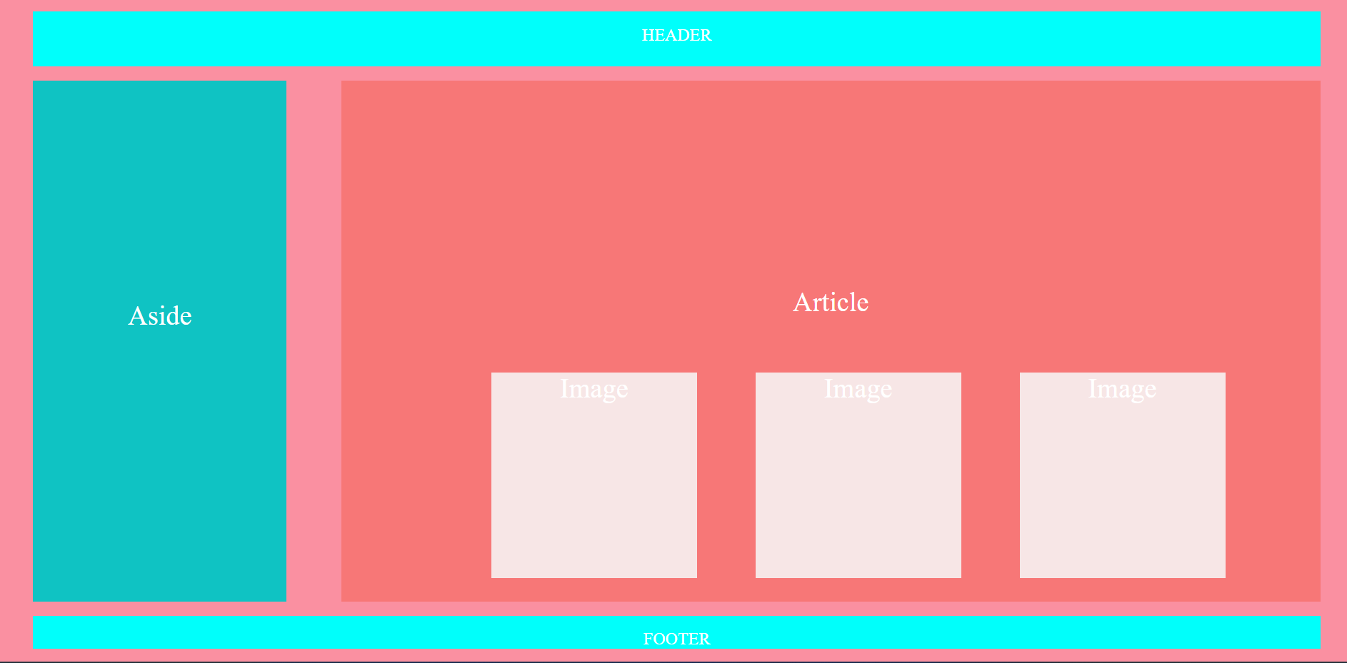

**Program 11**

**Problem Statement –** To create an HTML page to explain input and output using a calculator with the use of various predefined functions and objects in Javascript

**Code-**

<!DOCTYPE html>

<html lang="en">

<head>

<meta charset="UTF-8">

<meta http-equiv="X-UA-Compatible" content="IE=edge">

<meta name="viewport" content="width=device-width, initial-scale=1.0">

<title>Document</title>

<style>

*

{

padding: 0;

margin: 0;

}

.calc_box

{

margin-left: 36vmax;

margin-top: 10vmax;

margin-bottom: 10vmax;

background-color: rgb(246, 138, 156);

height:32vmax;

width:30vmax;

padding: 2vmax;

}

#input_calc

{

margin-left: 10vmax;

height: 2vmax;

}

.first_row,.second_row,.third_row,.forth_row,.fifth_row{

padding: 2vmax;

border-left: 2vmax;

}

.button

{

margin-left: 4vmax;

text-decoration: solid;

font-size: 2vmax;

width: 30px;

border-radius: 2px 4px;

}

</style>

</head>

<body>

<div class="calc_box">

<input type="text" id="input_calc"/>

<div class="first_row">

<button class="button" value="7" onclick="input_calc.value+='7'">7</button>

<button class="button" value="8" onclick="input_calc

.value+='8'">8</button>

<button class="button" value="9" onclick="input_calc

.value+='9'">9</button>

<button class="button" value="9" onclick="input_calc

.value+='+'">+</button>

</div>

<div class="second_row">

<button class="button" value="4" onclick="input_calc

.value+='4'">4</button>

<button class="button" value="5" onclick="input_calc

.value+='5'">5</button>

<button class="button" value="6" onclick="input_calc

.value+='6'">6</button>

<button class="button" value="-" onclick="input_calc

.value+='-'">-</button>

</div>

<div class="third_row">

<button class="button" value="1" onclick="input_calc

.value+='1'">1</button>

<button class="button" value="2" onclick="input_calc

.value+='2'">2</button>

<button class="button" value="3" onclick="input_calc

.value+='3'">3</button>

<button class="button" value="*" onclick="input_calc

.value+='*'">*</button>

</div>

<div class="forth_row">

<button class="button" value="0" onclick="input_calc

.value+='0'">0</button>

<button class="button" value="%" onclick="input_calc

.value+='%'">%</button>

<button class="button" value="." onclick="input_calc

.value+='.'">.</button>

<button class="button" value="/" onclick="input_calc

.value+='/'">/</button>

</div>

<div class="fifth_row">

<button class="button" value="=" onclick="input_calc.value = eval(input_calc.value) ">=</button>

<button class="button" value="c" onclick="input_calc.value = ' ' ">C</button>

</div>

</div>

</body>

</html>

**OUTPUT**

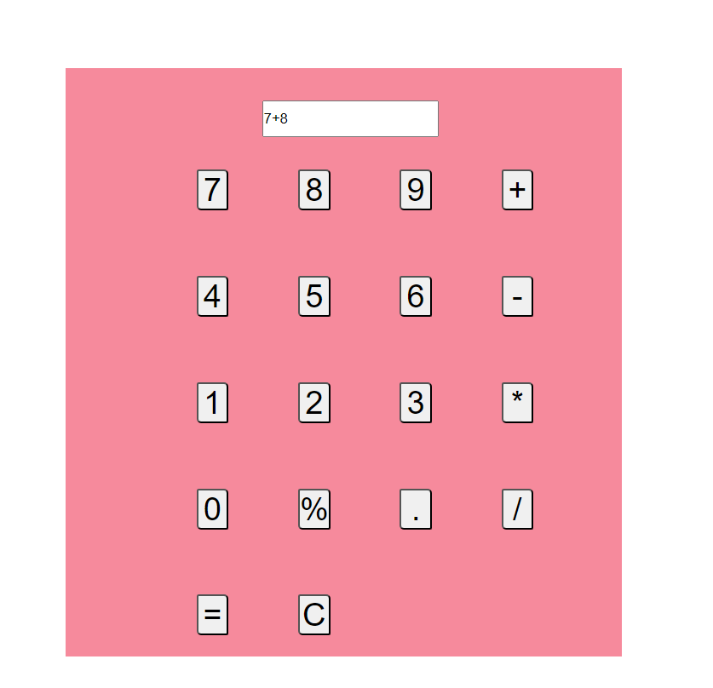

**Program 12**

**Problem Statement** – To create an html page to explain the use of various predefined functions in window object in java script.

**Code** –

<!DOCTYPE html>

<html lang="en">

<head>

<meta charset="UTF-8">

<meta http-equiv="X-UA-Compatible" content="IE=edge">

<meta name="viewport" content="width=device-width, initial-scale=1.0">

<title>Document</title>

<style>

.in

{

background-color: rgb(247, 186, 206);

height: 27vmax;

width: 20vmax;

margin-left: 38vmax;

margin-top: 4vmax;;

margin-bottom: 4vmax;

}

#b1

{

margin-left: 7vmax;

margin-top: 2vmax;

}

#b2

{

margin-left: 7vmax;

margin-top: 2vmax;

}

#b3,#haha

{

margin-left: 6vmax;

margin-top: 2vmax;

}

#b4

{

margin-left: 6vmax;

}

#b5,#b6,#b7

{

margin-top: 2vmax;

margin-left: 6vmax;

}

</style>

</head>

<body>

<div class="in">

<button id="b1" onclick="alert('I am fine')">hii how are you</button>

<button id="b2" onclick="alert('tumse mtlb')">Example of alert </button>

<button id="b3" onclick="handshake()">Handshake with me</button>

<p id="haha"></p>

<button id="b4">Click me to confirm </button>

<button id="b5" onclick="windowOpen()">Open Any website</button>

<button id="b6" onclick="windowClose()">Close this website</button>

<button id="b7" onclick="window.print()">Example of print</button>

</div>

<script>

function handshake()

{

var doc=prompt("Please enter your name ","Doremon")

if(doc!=null)

{

document.getElementById('haha').innerHTML="have to meet you "+doc;

}

}

var el=document.getElementById(b4);

b4.onclick=function()

{

confirm("Press Ok to close this prompt");

}

function windowOpen()

{ Window=window.open("https://www.geeksforgeeks.org/","_blank","width=400,height=300,top=230,left=540");

}

function windowClose()

{

Window.close();

}

</script>

</body>

</html>

**OUTPUT**

**Alert ->**

**Prompt ->**

**Confirm ->**

**Open ->**

**Print ->**

**Program 15**

**Problem Statement-** To create an html page to change the background color for every click of a button using javascript.

**Code –**

<!DOCTYPE html>

<html lang="en">

<head>

<meta charset="UTF-8">

<meta http-equiv="X-UA-Compatible" content="IE=edge">

<meta name="viewport" content="width=device-width, initial-scale=1.0">

<title>Document</title>

</head>

<body>

<div style="font-size: 50px" class="main-div">

Click here to change the color

</div>

</body>

<script>

var clickableDiv=document.body;

clickableDiv.addEventListener('click',function () {

var randomColor=getRandomColor();

document.body.style.backgroundColor=randomColor;

})

function getRandomColor() {

var letters = "0123456789ABCDEF";

var color = "#";

for (var i = 0; i < 6; i++) {

color += letters[Math.floor(Math.random() * 16)];

}

return color;}</script></html>

**Output**

**Before clicking**

**After clicking**

**Program 16**

**Problem Statement** - : To create an html page with 2 combo box populated with month & year, to display the calendar for the selected month & year from combo box using javascript.

**Code –**

<!DOCTYPE html>

<html lang="en">

<head>

<meta charset="UTF-8">

<meta http-equiv="X-UA-Compatible" content="IE=edge">

<meta name="viewport" content="width=device-width, initial-scale=1.0">

<style>

td{

text-align: center;

}

#output {

margin-top: 2rem;

display: flex;

justify-content: center;

}

</style>

<title>Calendar</title>

</head>

<body>

<h1>Calendar</h1>

<h2>Select Year</h2>

<select name="year" id="year">

</select>

<h2>Select Month</h2>

<select name="month" id="month">

<option value="0">Jan</option>

<option value="1">Feb</option>

<option value="2">Mar</option>

<option value="3">Apr</option>

<option value="4">May</option>

<option value="5">Jun</option>

<option value="6">jul</option>

<option value="7">Aug</option>

<option value="8">Sep</option>

<option value="9">Oct</option>

<option value="10">Nov</option>

<option value="11">Dec</option>

</select>

<button id="ok">ok</button>

<div id="output">

</div>

<script >

const year = document.getElementById('year');

const month = document.getElementById('month');

const btn = document.getElementById('ok');

const monthName = ['January', 'February', 'March', 'April', 'May', 'June', 'July', 'August', 'September', 'October', 'December'];

const output = document.getElementById('output');

const days = [31, 28, 31, 30, 31, 30, 31, 31, 30, 31, 30, 31];

for(var i = 1990; i < 2050; i++)

{

year.innerHTML += `<option value = ${i}>${i}</option>`;

}

btn.addEventListener('click', (e) => {

var m = +month.value + 1;

var D = year.value % 100;

var C = Math.floor(year.value / 100);

var last = days[month.value];

if(m > 2)

m -= 2;

else

{

m += 10;

D -= 1;

}

var f = 1 + Math.floor((13 * m - 1) / 5) + D + Math.floor(D / 4) + Math.floor(C / 4) - 2 * C;

if(f < 0)

f = 7000 + f;

f = f % 7;

outputHTML = `<table border='2' cellpadding='20'> <tr><th colspan='7'>${monthName[month.value]} ${year.value}</tr> <tr><th>Sun</th><th>Mon</th><th>Tue</th><th>Wed</th><th>Thur</th><th>Fri</th><th>Sat</th></tr>`

var count = 1;

var row = '<tr>'

for(var temp = 0; temp < f; temp++)

row += '<td></td>';

for(var c = f; c < 7; c++)

{

row += '<td>${count}</td>';

count += 1;

}

row += '</tr>';

outputHTML += row;

while(count <= last)

{

row = '<tr>'

var tot = 0;

for(; tot < 7 && count <= last; tot++, count++)

row += `<td>${count}</td>`;

row += '</tr>';

outputHTML += row;

}

outputHTML += '</table>';

output.innerHTML = outputHTML;

})

</script>

</body>

</html>

**OUTPUT**

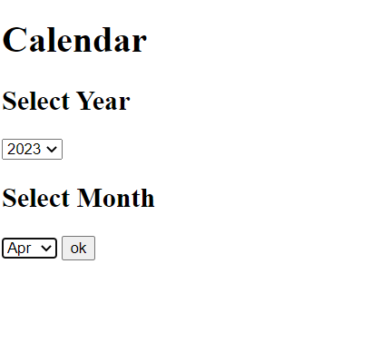

**Program 18 (a)**

**Problem statement –** Write a JavaScript program to display the current day and time in the following format.

**Sample Output :** Today is : Friday. Current time is : 4 PM : 50 : 22

**Code –**

<!DOCTYPE html>

<html lang="en">

<head>

<meta charset="UTF-8">

<meta http-equiv="X-UA-Compatible" content="IE=edge">

<meta name="viewport" content="width=device-width, initial-scale=1.0">

<title>Document</title>

</head>

<body>

<p>Javascript dates</p>

<script>

var today=new Date();

var day=today.getDay();

console.log(day);

var dayList=["Sunday","Monday","Tusesday","Wednesday","Thursday","Friday","Saturday"];

console.log("Today is : "+dayList[day]);

var hour=today.getHours();

var minute=today.getMinutes();

var second=today.getSeconds();

var ampm=(hour>=12)?" PM":" AM";

hour=(hour>=12)?hour-12:hour;

if(hour === 0 && ampm===' PM')

{

if(minute === 0 && second === 0)

{

hour=12;

ampm=' Noon';

}

else

{

hour=12;

ampm=' PM';

}

}

if(hour === 0 && ampm === ' AM')

{

if(minute === 0 && second ===0)

{

hour=12;

ampm=' Midnigh';

}

else

{

hour=12;

ampm=' AM';

}

}

console.log("Current Time: "+hour+ampm+" : "+minute+" : "+second);

</script>

</body>

</html>

**OUTPUT –**

Today is :Friday

Cyrrent Tine :9 PM : 2:9

**Program 18(b)**

**Problem Statement** – Write a JavaScript program to get the current date. Expected Output : mm-dd-yyyy, mm/dd/yyyy or dd-mm-yyyy, dd/mm/yyyy

**Code –**

<!DOCTYPE html>

<html lang="en">

<head>

<meta charset="UTF-8">

<meta http-equiv="X-UA-Compatible" content="IE=edge">

<meta name="viewport" content="width=device-width, initial-scale=1.0">

<title>Document</title>

</head>

<body>

<p>Javascript Date</p>

<script>

var today=new Date();

console.log(today);

var day=today.getDate();

var month=today.getMonth();

console.log(month);

var year=today.getFullYear();

console.log(year);

month =(month<=9)?'0'+month:month;

day=(day<=9)?'0'+day:day;

console.log(month+"-"+day+"-"+year);

console.log(month+"/"+day+"/"+year);

console.log(day+"-"+month+"-"+year);

console.log(day+"/"+month+"/"+year);

</script>

</body>

</html>

**Output** -

Fri Apr 14 2023 21:44:44 GMT+0530 (India Standard Time)

curr_date_format.html:15 14

curr_date_format.html:17 3

curr_date_format.html:19 2023

curr_date_format.html:22 03-14-2023

curr_date_format.html:23 03/14/2023

curr_date_format.html:24 14-03-2023

curr_date_format.html:25 14/03/2023

**Program 18 (c )**

**Problem Statement -** Write a JavaScript function to get difference between two dates in days. Test Data : console.log(date_diff_indays('04/02/2014', '11/04/2014')); console.log(date_diff_indays('12/02/2014', '11/04/2014')); Output : 216 -28

**Code –**

<!DOCTYPE html>

<html lang="en">

<head>

<meta charset="UTF-8">

<meta http-equiv="X-UA-Compatible" content="IE=edge">

<meta name="viewport" content="width=device-width, initial-scale=1.0">

<title>Document</title>

</head>

<body>

<p>Difference between Dates</p>

<script>

var date1 = new Date("06/14/2023");

var date2 = new Date("06/15/2023");

var Difference_In_Time = date2.getTime() - date1.getTime();

var Difference_In_Days = Difference_In_Time / (1000 * 3600 * 24);

console.log("Total number of days between "+date1+" and "+date2+" is : "+Difference_In_Days);

</script>

</body>

</html>

**OUTPUT**

Total number of days between Wed Jun 14 2023 00:00:00 GMT+0530 (India Standard Time) and Thu Jun 15 2023 00:00:00 GMT+0530 (India Standard Time) is : 1

**Program 18 (d)**

**Problem Statement** - Write a JavaScript function to count the number of days passed since beginning of the year. Go to the editor Test Data : console.log(days_passed(new Date(2015, 0, 15))); 15 console.log(days_passed(new Date(2015, 11, 14))); 348

**Code –**

<!DOCTYPE html>

<html lang="en">

<head>

<meta charset="UTF-8">

<meta http-equiv="X-UA-Compatible" content="IE=edge">

<meta name="viewport" content="width=device-width, initial-scale=1.0">

<title>Document</title>

</head>

<body>

<p>Begninning of the year</p>

<script>

function day_passed(dt)

{

var today=new Date(dt.getTime());

var prev=new Date(dt.getFullYear(),0,1);

//console.log(prev);

return Math.ceil((today-prev+1)/86400000);

}

console.log(day_passed(new Date(2023,5,14)));

</script>

</body>

</html>

**OUTPUT**

165

**Program 18(e )**

**Problem Statement** - Write a JavaScript program to find 1st January is being a Sunday between year1 and year2

**Code –**

<!DOCTYPE html>

<html lang="en">

<head>

<meta charset="UTF-8">

<meta http-equiv="X-UA-Compatible" content="IE=edge">

<meta name="viewport" content="width=device-width, initial-scale=1.0">

<title>Document</title>

</head>

<body>

<p>January</p>

<script>

let yr=2014;

while(yr<=2050)

{

if(new Date(yr,0,1).getDay() === 0)

{

console.log(yr+" ");

}

yr++;

}

</script>

</body>

</html>

**OUTPUT**

2017 2023 2034 2040 2045

**Program 18 (f)**

**Problem Statement -** Write a JavaScript program to calculate days left until next Christmas

**Code –**

<!DOCTYPE html>

<html lang="en">

<head>

<meta charset="UTF-8">

<meta http-equiv="X-UA-Compatible" content="IE=edge">

<meta name="viewport" content="width=device-width, initial-scale=1.0">

<title>Document</title>

</head>

<body>

<p>Until Next Christmas</p>

<script>

let todayDate = new Date();

console.log("Today's date is defined as: ", todayDate)

let christmasYear = todayDate.getFullYear();

if (todayDate.getMonth() == 11 && todayDate.getDate() > 25) {

christmasYear = christmasYear + 1;

}

let christmasDate = new Date(christmasYear, 11, 25);

let dayMilliseconds = 1000 * 60 * 60 * 24;

let daysLeft = Math.ceil(

(christmasDate.getTime() - todayDate.getTime()) / (dayMilliseconds)

);

console.log("The number of days left for christmas is: ")

console.log(daysLeft)

</script>

</body>

</html>

**OUTPUT - >** 225

**Program 18 (g)**

**Problem Statement** – Write a JavaScript program to calculate days remains in your birthday

**Code –**

<!DOCTYPE html>

<html lang="en">

<head>

<meta charset="UTF-8">

<meta http-equiv="X-UA-Compatible" content="IE=edge">

<meta name="viewport" content="width=device-width, initial-scale=1.0">

<title>Document</title>

</head>

<body>

<p>Birthday</p>

<script>

var today=new Date();

var birth=new Date('09-22-2023');

var diff=birth.getTime()-today.getTime();

var dif_days=diff/(1000 * 3600 * 24);

console.log(dif_days);

</script>

</body>

</html>

**OUTPUT-**

160